Vegetation along the Mongarlowe River north of the Kings Highway

Prepared by Keith McDougall ([keith.mcdougall@environment.nsw.gov.au](mailto:keith.mcdougall@environment.nsw.gov.au)); October 2014

The riparian zone along the banks of the Mongarlowe River is typically dominated by Ribbon Gum (*Eucalyptus viminalis*) with abundant shrubs (e.g. *Grevillea juniperina* subsp. *villosa*), Spiny-headed Mat-rush (*Lomandra longifolia*) and ferns in the understorey. The shrubs can be very dense at times and it is easy to forget that the prickly grevillea that is so abundant in the Mongarlowe Valley is only known from the Mongarlowe and Corang River catchments. In gentle-flowing stretches of the river it is common to see the Entire Marshwort (*Nymphoides geminata*), with its yellow flowers, floating on the water surface. Despite its botanical name it is not closely related to the water lily of northern Australia. It is however, one of the few local native species that you could also find in New Guinea.

The plant community beside the river has been given the name Tableland Swamp Flats Forest, which occurs from the Jenolan Caves area to Bombala. Native species commonly found along the Mongarlowe River include:

**Trees**

*Eucalyptus viminalis* (along the river bank)

*Eucalyptus radiata* (Narrow-leaved Peppermint)*, Eucalyptus rubida* (Candlebark)*, Eucalyptus pauciflora* (Snowgum; upslope).

**Shrubs**

*Acacia trachyphloia* (Bodalla Wattle)

*Baeckea utilis* (Mountain Baeckea)

*Bursaria spinosa* subsp. *Lasiophylla* (Blackthorn)

*Epacris calvertiana*

*Epacris microphylla* (Coral Heath)

*Grevillea juniperina* subsp. villosa

*Hakea microcarpa* (Small-fruit Hakea)

*Leptospermum lanigerum* (Woolly Tea-tree)

*Lomatia myricoides* (River Lomatia)

*Pomaderris pauciflora*

*Prostanthera lasianthos* (Christmas Bush)

*Pultenaea altissima* (Tall Bush-pea)

*Rubus parvifolius* (Native Raspberry)

**Grasses and grass-like plants**

*Lomandra longifolia* (Spiny-headed Mat-rush)

*Microlaena stipoides* (Weeping Grass)

**Forbs, ferns etc**

*Acaena novae-zelandiae* (Bidgee-widgee)

*Blechnum nudum* (Fishbone Water Fern)

*Dichondra repens* (Kidney Weed)

*Geranium potentilloides*

*Gonocarpus micranthus* (Creeping Raspwort)

*Gratiola peruviana* (Australian Brooklime)

*Lagenophora stipitata*

*Plantago debilis*

*Poranthera microphylla*

*Pteridium esculentum* (Austral Bracken)

*Ranunculus lappaceus* (Common Buttercup)

*Senecio prenanthoides*

*Stellaria pungens* (Prickly Starwort)

*Veronica plebeia* (Trailing Speedwell)

Rare, threatened and interesting plants of the Mongarlowe River valley

Eleven species growing in the Mongarlowe River catchment are listed as threatened under NSW legislation. Several others are rare.

**Dense Cord-rush (*Baloskion longipes*, a grass-like plant)**

Listed as vulnerable under Commonwealth and NSW legislation. In the Mongarlowe River valley it is only known beside the Kings Highway near the top of the Clyde but could occur in other wet places.

**Scented Bitter-pea (*Daviesia suaveolens*, Pea family)**

A tall shrub (to 6 m), which is rare. It occurs in Monga National Park where it is at the northern end of its range.

**Michelago Parrot-pea (Dillwynia glaucula, Pea family)**

Listed as vulnerable under NSW legislation. A shrub to about 1.5 m tall with very narrow, bluish coloured leaves. In the Mongarlowe Valley it is known from the Nettleton Creek area on rocky ridges.

**Pale Golden Moths (*Diuris ochroma*, Orchid family)**

Listed as vulnerable under Commonwealth and endangered under NSW legislation. A type of donkey orchid that is distinguished by its purple markings on the pale yellow flowers. In NSW it is only known from near Kybean (east of Cooma) and in Kosciuszko National Park but only about 200 plants have been recorded. A few plants were discovered in 2005 on the edge of the Kings Highway near Misty Mountain Nursery but they have not been seen since. It generally flowers in early summer.



*Diuris ochroma*, Photo: Jackie Miles

**Black Gum (*Eucalyptus aggregata*, Eucalypt family)**

Listed as vulnerable under NSW legislation. Occurs from western Melbourne to western Sydney but rarely common. There have been several records in the Mongarlowe Valley, most of them old. One of the first records was made by Wilhelm Baeuerlen (see below) in ‘Fagan’s Creek, Braidwood District’, late 19th Century. Black Gum is a tree to 18 m high with grey-black, fibrous-flaky bark to its highest branches. Adult leaves are 5–12 cm long and 1–2 cm wide, green and glossy. Flowers are in groups of 7. Buds are 3–5 mm long and 2–3 mm diam. Fruits are cone-shaped, 2–4 mm long and 3–5 mm diam.

**Wolgan Snow Gum (*Eucalyptus gregsoniana*, Eucalypt family)**

A rare mallee eucalypt that occurs in the Blue Mountains, the Windelllama area and a few locations of the Southern Tablelands including the Mongarlowe River valley. Very similar in appearance to Snow Gum but has multiple stems, and sometimes narrower leaves and fewer than 11 flowers in a cluster.

**Mongarlowe Mallee (*Eucalyptus recurva*, Eucalypt family)**

Listed as endangered under Commonwealth and critically endangered under NSW legislation. Found in the Half Moon area of Mongarlowe with an isolated population at Windellama. There are only four populations in total, each comprising a single plant. It is found in shallow soils on gentle slopes in low heathland and in some cases at the margins of the heathland and adjacent low woodland; in the Mongarlowe area the heathland is dominated by Stunted She-oak (*Allocasuarina nana*), with emergent shrubs of Finger Hakea (*Hakea dactyloides*). Flowering occurs in January. The plants set very few seeds so the chance of recruitment of new individuals in the field is low. The size and spread of the lignotubers (woody underground structures) suggests that the plants are of considerable age, probably several hundred years.

**Purple Eyebright (*Euphrasia collina* subsp. *speciosa*, Snapdragon family)**

These unusual plants are not rare throughout their range (scattered in south-eastern Australia) but the Mongarlowe population is quite isolated and becoming rare because of road maintenance works. They flower in spring and can be seen near the cemetery and along Budawang Rd. *Euphrasias* are parasitic plants; their roots latch onto roots of other species, pinching nutrients for the early stages of growth. An extract from *Euphrasia* species in Europe has been used since the 16th Century for the treatment of eye inflammations (hence the common name). It is still available as a herbal remedy for the treatment of conjunctivitis (inflammation or infection of the membrane lining the eyelids), as an eye wash, to relieve hay fever, sinusitis, upper respiratory tract infections and catarrh, and to aid in the healing on skin wounds.

**Superb Midge Orchid (*Genoplesium superbum*, Orchid family)**

Listed as endangered under NSW legislation. Once thought to occur only in Morton National Park between Sassafras and Nerriga, this orchid was found recently in Mongarlowe (on Charleys Forest Road and just off Northangera Rd). It flowers in March after good summer rain and is a species to keep an eye out for in open woodland.

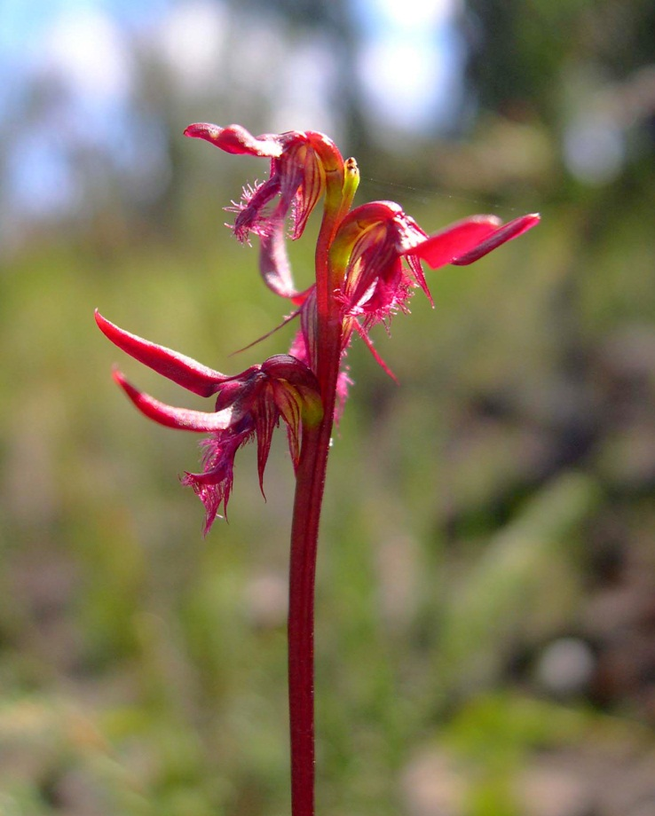 *Genoplesium superbum*

**A Grevillea (*Grevillea imberbis*, Banksia family)**

A low shrub with small white or pink flowers, known from two very separate areas, the Boyd Plateau near Oberon and Mongarlowe (Charleys Forest to Currockbilly but apparently not very common).

**Nerriga Grevillea (*Grevillea renwickiana*, Banksia family)**

Listed as endangered under NSW legislation. This is a prostrate, holly-leaved *Grevillea* that occurs between Nerriga and Nettletons Creek (north of Mongarlowe). Flowers are rarely seen and fruits have never been recorded. Spread occurs by underground stems. Recent genetic work has found that the nine populations of this species contain nine clones in total. One population contains two clones and all of the others have just one clone. However, two populations separated by more than 1 km have the same clone – that plant has probably been spreading there for hundreds or thousands of years. The Nettletons Creek population is especially interesting because plants on both sides of the deeply incised creek are genetically identical – i.e. at some stage they were connected.

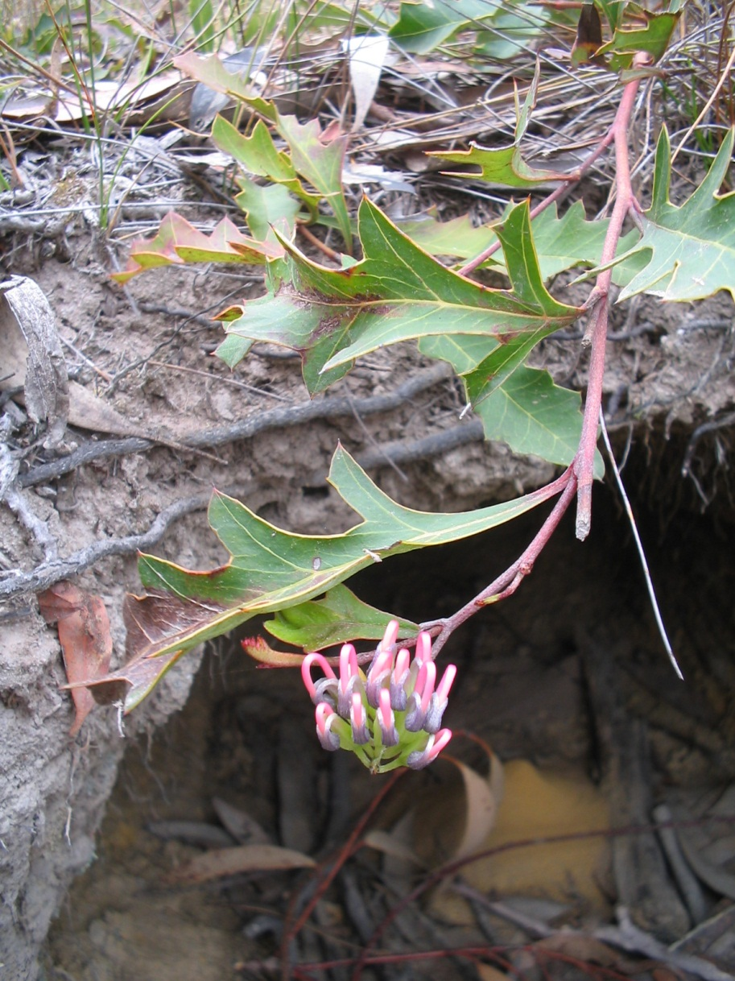

*Grevillea renwickiana*; photo: Gavan McCarthy

**Monga Tea Tree (*Leptospermum thompsonii*, eucalypt family)**

Listed as vulnerable under NSW legislation. This tall shrub is very common in swampy areas and along the Mongarlowe River in Monga National Park. It even germinates well on road verges.

**A Rice-flower (*Pimelea curviflora* var. *acuta*, Daphne family)**

Not listed as threatened but not especially common either and the population near Mongarlowe is quite isolated from other populations (the nearest being in the ACT). It is fairly common along Feagans Creek.

**Budawangs Wallaby Grass (*Plinthanthesis rodwayi*, Grass family)**

Listed as endangered under NSW legislation. Currently only known from the summit of Mt Budawang although it once occurred on the summit of Mt Currockbilly too (the recent fires there may allow it to re-appear). A very palatable grass – it prospers on Mt Budawang only because of the wombat-proof fence.

**Mountain Pomaderris (*Pomaderris pauciflora*, Rhamnaceae family containing *Ceanothus*, *Spyridium* etc)**

A rare shrub 1 – 3 m tall, mostly from East Gippsland with scattered populations in NSW, especially along the Shoalhaven and Mongarlowe Rivers. Tends to be riparian. Was collected frequently from the river crossing of Little River Rd but seems to have disappeared from there.

**Budawangs Bush-pea (*Pultenaea baeuerlenii*, Pea family)**

Listed as vulnerable under NSW legislation. This suckering shrub grows to about 1 m tall. It is known from only three areas in the Budawangs but maybe more common because most suitable habitat is in remote areas. A population on Mt Curockbilly was burnt in the 2013 fire but is slowly regenerating. The species is named after Wilhelm Baeuerlen, a German migrant who collected thousands of botanical specimens for Ferdinand von Mueller and J.H. Maiden (big name Australian botanists) in eastern Australia in the 19th and early 20th centuries. He made many collections in the Mongarlowe area in 1898. Some have been seen rarely since (e.g. the only record of *Podolepis longipedata* within about 200 km).

**Monga Waratah (*Telopea mongaensis*, Banksia family)**

Although this striking species bears a local name, it occurs as far north as Meryla State Forest (near Moss Vale) with a 19th Century record from Wentworth Falls in the Blue Mountains. A nice find though when you see one in flower.

**Alpine Sun Orchid (*Thelymitra alpicola*, Orchid family)**

Proposed for listing as vulnerable under NSW legislation. Recorded close to the Kings Highway at the top of the Clyde.

Some plants that shouldn’t be in the Mongarlowe River valley

**Winged Everlasting (*Ammobium alatum*, Daisy family)**

This is an Australian species but its native range and habitat are uncertain because it is so good at colonising disturbed ground and has spread to many new locations – i.e. it behaves like many weeds. It is probably native to the Northern Tablelands of NSW but is almost certainly an introduction in the ACT / Braidwood and Jindabyne areas. It is very abundant on the Kings Highway near the Misty Mountain nursery and has spread in abundance onto neighbouring paddocks in the last decade. It has also been seen on Charleys Forest Rd. Worth pulling out if you see any isolated occurrences. Widely planted in Braidwood township where it has spread onto lawns and footpaths.

**English Broom (*Cytisus scoparius*, Pea family)**

Currently not as abundant in the Mongarlowe valley as in the Shoalhaven valley, and best to keep it that way. Plants flower prolifically in October and should be pulled out as soon as they appear. Seed lives in the soil for almost a century so good to get rid of it before it sets seed.

**African Lovegrass (*Eragrostis curvula*, Grass family)**

Perhaps not yet along the Mongarlowe River (apart from close to its junction with the Shoalhaven). Gets very dense in sandy areas of the Shoalhaven River (e.g. Bombay) and can be detrimental for farming.

**Oxeye Daisy (*Leucanthemum vulgare*, Daisy family)**

Despite its good looks, this is a very menacing species for both agriculture and the environment. Recent work in Kosciuszko National Park has shown that it is a very cunning and effective weed. There it went from obscurity to out of control in the space of a year. How is that possible? Firstly, individual plants can produce up to 26,000 seeds / year. In a dense population that is 100 million seeds / ha / year. The half-life of seeds is about 20 years but not all germinate at once. Seeds are not dispersed by wind but they can travel long distances on the fur of animals or shoes of humans or mud on vehicles. Secondly, young plants can survive for some years as suppressed seedlings amongst dense native vegetation. Finally, when native cover is reduced (e.g. after a fire), the seedlings can grow faster than most native plants and, under ideal conditions, can go from seedling to seed-producing adult in two months. Oxeye Daisy can still be purchased from nurseries and can be safely grown in gardens by cutting the flowers off before they go to seed. It is a native of Europe but even there it is showing signs of expanding its range into high altitude areas.

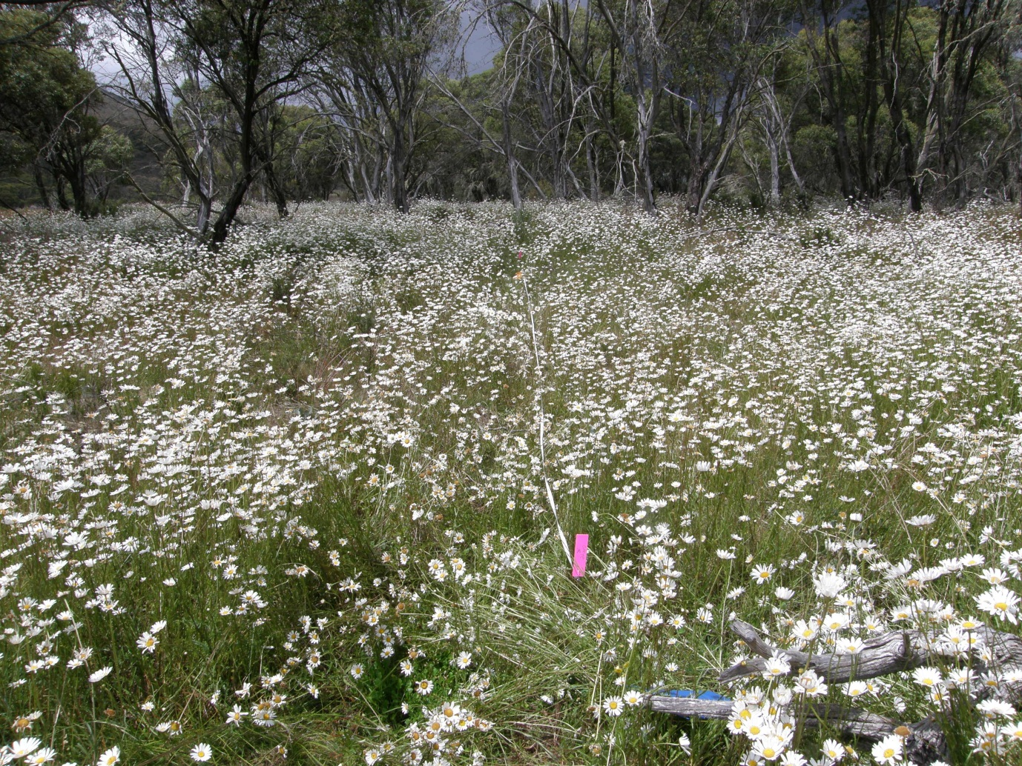

Oxeye daisy invasion into natural snow gum woodland in Kosciuszko National Park

**Water Forget-me-not (*Myosotis laxa* subsp. *caespitosa*, Borage family)**

Recorded from Bobs Creek in Charleys Forest, this pathetic but attractive looking herb can grow en masse and choke small waterways. Impossible to get rid of once established so good to keep an eye out for it and remove when it first arrives.

**Serrated Tussock (*Nassella trichotoma*, Grass family)**

This grass has been recorded near the confluence of the Mongarlowe and Shoalhaven Rivers and is perhaps not yet in the Mongarlowe catchment. However, it is locally abundant on the western side of the Shoalhaven so there is no reason it won’t become abundant here too. Often confused with native River Tussock (*Poa labillardierei*), except when in flower.

**Blackberry (*Rubus ulmifolius*, Rose family)**

Already widespread in the catchment and continually dispersed by birds. Biological control may be the only hope for this species.

**Fireweed (*Senecio madagascariensis*, Daisy family)**

Perhaps not yet in the Mongarlowe Valley but recorded recently near Nerriga and in the ACT. Will be mainly an issue for agriculture but there is likely to be collateral damage from herbicide programs to the similar-looking native species *S. pinnatifolius*. Despite some identification guides for *S. madagascariensis*, which suggest that it can be identified by the number of ‘petals’, identification is not so easy.